Connect to parent – FAFA

(communicate tool for kids via voice recognition)

Park Hyeong Jin   
2016026271 *Dept. of Information System*  
College of Engineering, *Hanyang University*Seoul, Rep. of Korea  
Email : jin5378@hanyang.ac.kr

Lee Jeong Seon  
2016026435 *Dept. of Information System*  
College of Engineering, *Hanyang University*Seoul, Rep. of Korea  
Email : com2769@gmail.com

Lee Jun Seok  
2016026444 *Dept. of Information System*  
College of Engineering, *Hanyang University*Seoul, Rep. of Korea  
Email : junslee0912@gmail.com

Yoon Seung Gwon  
2016026371 *Dept. of Information System*  
College of Engineering, *Hanyang University*Seoul, Rep. of Korea  
Email : csyoon1472@gmail.com

*Abstract*— FAFA is a parent-child connection service that is powered by artificial intelligence based voice recognition technology. The penetration rate of mobile phones among South Korea's senior elementary school students surpassed 90% in 2018. However, the gap between the lower grade of elementary school(58.8%) is too big, and it is expected to be bigger if in kids are included. In addition, the penetration rate of fixed-line telephones in households was 51.9% in 2019, the lowest ever. Given the trend of these figures, two-way communication between parents and children under the lower grades of elementary school will become more difficult.

To solve this problem, we developed FAFA service which is based on voice recognition and web. The service tells parent’s location information for kid and sends message to parent that kid is looking for you. This service will enable two-way communication with parents and kids.

**1. Introduction**

**Motivation**

Child Location Based Services (LBS), which is widely used by parent, is a child management service for parents. Parents who are concerned about their child’s safety check their child's current location through the LBS service. However, parents are not the only ones who worry about their child Their child also wants to know where their parents are now and when they will come back home. Also, children who are left alone at home want to communicate with their parents. We understood these demands and felt the need for a way to communicate child at home with parents.

**Problem statement(kid’s need)**

According to a report by the Korea Information Society Development Institute, the penetration rate of mobile phones in the lower grades children of elementary school in 2018 was 58.8%. Including preschoolers, more than half of children under the age of 10 don't have cell phones. In addition, the penetration rate of landline phones in 2018 was 51.9%.Parents are reluctant to buy their young children's cell phones for various reasons, including their children's addiction to smartphones and the burden of costs. When young children are alone at home, they often want to communicate with parents when they come to the house and where they are. However, they can’t contact their parent due to the absence of communication means. In order to solve the demand for communication with young children and parents, we propose a "parent-child connection" service that use NUGU speakers.

**Solution**

FAFA is a parent-child communication service by artificial Intelligence speech recognition technology of SKTelecom’s NUGU speaker. By using FAFA, Young child can know that when their parents will come home and where they are now. When the child asks the NUGU speaker where the parents are, it searches parent’s location and informs it. Also, When the child arrives at home and talks to the NUGU speaker, the alert goes off on parent’s cell phone via web server. The FAFA service uses NUGU speaker installed in home to provide communication between parents and children at no additional cost.

**Research on any related software**

1) iSharing Lifestyle

iSharing by iSharingSoft is an app that provides a real-time locator service allowing family members and close friends to privately share their location information and communicate with each other. iSharing help parents and caregivers reduce anxiety around the whereabouts of their loved ones with easy tracking and alerting messages. There are four main functions.

1. Place alert : receive real-time alerts when family arrive at or leave destination
2. Panic alert : Just shake phone to send notification messages to your family member
3. Walkie-Talkie : Turn your phone into a Walkie-Talkie.
4. Location History : See the location history of family member

2) NUGU call

'NUGU-to-NUGU Call' is service about talking to your NUGU device or NUGU call subscriber.

This call is linked to data. You can use ‘normal mode’ to non NUGU call subscriber. A phone call is linked through the mobile phone of the account connected to the NUGU device.

3) NUGU SOS

SOS service is that sends pre-set text messages to designated recipients. You can set the sender's and recipient's information and the emergency SOS message to be sent. If you request an emergency SOS to the NUGU speaker, we will send an emergency SOS message to your registered number.

4) KAKAO mini

You can use Kakao Mini to send and read messages you received from users you want. Kakao Mini reads new messages from Kakao Talk's 1:1 chat room and group's Kakao Talk chat room. It reads messages from friends and reply. If it is not a text message, such as an emoticon or video, it tells the format of the message.

**2. Requirements**

**2.1 AI Speaker (for kid)**

**2.1.1 Ask & Answer parent’s location via voice**

1) Set expected utterance that kid’s intent is asking parent’s location

2) Process parent’s location in backend proxy based on entity

3) Get parent’s location and status. NUGU speaker will tell result using TTS function

**2.1.2 Send alert to parent**

1) Send request to backend proxy when kids find their parents or tell speaker that they get home

2) Server keep these request logs in database

**2.1.3 Inform that child has arrived home via voice**

1) Set expected utterance that kid’s intent is informing that they arrived home

2) Send request to backend proxy server

3) Server keep request logs in database

**2.2 Application (for parent)**

**2.2.1 Log-in**

1) To identify users, token(user ID) is required

**2.2.2 Set location of home and company**

1) To judge parent’s location and status, need to set longtitude and latitude of home and company

2) User could set marker on map

**2.2.3 Update present location**

1) Send present longtitude and latitude data to server

**2.2.4 View kid’s request log**

1) Provide log of kid’s request in customized UI

**2.3 Server**

**2.3.1 Judge parent’s location**

1) Get parent’s location data from application

2) Check latest location and judge status by customized algorithm

3) Response to NUGU

**2.3.2 Send data to database**

1) Server get data from NUGU speaker and application

2) Server keep these data in database

**2.3.4 Make json for NUGU**

1) Server should make json file. NUGU speaker demand data in REST API form

**3. Development Enviroment**

**3.1 Software Development Platforms**

We chose native app to develop our project, and server acts as REST API. Web environment could also send location data, but we need more precise data and want it to be updated automatically. React Native which is front-end framework is used. Django which is back-end framework is used for developing REST API to connect with NUGU.

In addition, we will use AWS commercial cloud service such as Elastic Beanstalk for deploy. Lastly, SKT’s NUGU API will be used to analyze kids’ utterance and to recognize their intent.

**3.1.1 React Native**

React Native is a JavaScript framework for writing real, natively rendering mobile applications for iOS and Android. It’s based on React, Facebook’s JavaScript library for building user interfaces, but instead of targeting the browser, it targets mobile platforms. Similar to React for the Web, React Native applications are written using a mixture of JavaScript and XML-esque markup, known as JSX.

**3.1.2 Django (web framework)**

Django is a Python-based free and open source web framework that follows the model-template-views(MTV) architectural pattern. It is maintained by the Django Software Foundation. Django's primary goal is to ease the creation of complex, database-driven websites. The framework emphasizes reusability and "pluggability" of components, less code, low coupling, rapid development, and the principle of don't repeat yourself. Python is used throughout, even for settings files and data models.

**3.1.3 SQLite**

SQLite is a relational database management system (RDBMS) contained in a C library. In contrast to many other database management systems, SQLite is not a client–server database engine. Rather, it is embedded into the end program. SQLite is a popular choice as embedded database software for local/client storage in application software such as web browsers. It is arguably the most widely deployed database engine, as it is used today by several widespread browsers, operating systems, and embedded systems (such as mobile phones), among others. SQLite has bindings to many programming languages.

**3.1.4 Amazon Web Service Elastic Beanstalk(EB)**

AWS Elastic Beanstalk is an orchestration service offered by Amazon Web Services for deploying applications which orchestrates various AWS services, including EC2, S3, Simple Notification Service (SNS), CloudWatch, autoscaling, and Elastic Load Balancers. Elastic Beanstalk provides an additional layer of abstraction over the bare server and OS; users instead see a pre-built combination of OS and platform.

**3.1.5 SKTelecom NUGU API**

Based on SK Telecom’s technical skills such as voice recognition, voice synthesis and understanding of natural language through NUGU developers, the company can develop new functions through voice command in devices or applications owned by its affiliates. We will recognize and categorize the user’s voice commands through the NUGU API and send output results to the user via voice.

**3.1.6 Google Maps API**

The Google Map API provides a variety of functions to produce map-based services on Web (Javascript) and mobile applications (Android, iOS). Local API provides contents and data of Google Map through REST API method.

**3.2 Programming Languages**

**3.2.1 Javascript**

Javascript is a high-level, interpreted scripting language that conforms to the ECMAScript specification. Javascript has flexible grammars: freedom from indentation, loose type checks. Also, it adopts modern progamming padigms and has convenient and great features: function programming, reactive programming. By using this language we can learn various modern progamming paradigms. Javascript is used in web browsers, which means it does not require any special working environment to run program written by Javascript.

**3.2.2 Python**

Python is an interpreted, high-level and general-purpose programming language. Created by Guido van Rossum and first released in 1991, Python's design philosophy emphasizes code readability with its notable use of significant whitespace. Its language constructs and object-oriented approach aim to help programmers write clear, logical code for small and large-scale projects.

**3.3 Cost Estimation**

This project rely on Amazon Web service. The cost estimation is in Table 1. This is calculated by Amazon Web Service Cost Calculator.

TABLE 1. COST ESTIMATION

|  |  |  |
| --- | --- | --- |
| **Service** | **Region** | **Cost(monthly)** |
| Amazon EC2 | US West (Oregon) | USD($) 11.65 |
| Google Maps API | - | USD($) 0.00 (Free) |

**3.4 Development Enviroment Description**

Used development enviroment tools information is described in Table 2.

TABLE 2. DEVELOPMENT ENVIROMENT TOOLS

|  |  |  |
| --- | --- | --- |
| **Name** | **Version** | **Description** |
| Windows | 10 Home | Operating System made by Microsoft |
| macOS | Catalina(10.15) | Operating System made by Apple, used in Macbook |
| Visual Studio code | 1.50.1 | Text editor and integrated development editor made by Microsoft |

**3.5 Market Research & Software in Use**

**3.5.1. Market research**

Location-based service(LBS) market size stood at USD 16.14 billion in 2018 and is expected to reach USD 66.61 billion by 2026. There are lots of services based on LBS, and one of the most popular services is the tracking services which provide the location of somebody for safety or other reasons. Most of these applications are for the parents who concern about their child’s safety. For example, ‘iSharing’ and ‘Google family link’ are one of the popular apps that provides a real-time locator service allowing family members and close friends to privately share their location. However, kids who don’t have mobile phones cannot use these apps, and these apps are mainly for parents who want to know their kids’ locations. There are not many services for children. Also, ‘Zenly’ is the most popular social networking apps among teenager and it surpassed 10 million users in 2019. It provides a map that lets users see their friends and what they are up to. In the case of ‘Zenly’, we find out teenagers wonder about what their parents are doing and where they are.

**3.5.2. Voice Recognition AI**

Voice or speaker recognition is the ability of a machine or program to receive and interpret dictation or to understand and carry out spoken commands. Voice recognition has gained prominence and use with the rise of [AI](https://searchenterpriseai.techtarget.com/definition/AI-Artificial-Intelligence) and intelligent assistants, such as Nugu, Siri, and Bixby. Voice recognition systems enable consumers to interact with technology simply by speaking to it, enabling hands-free requests, reminders and other simple tasks.

**3.5.3. Located-based services (LBS)**

Location-based services offer a wide range of opportunities because of their ability to provide information associated with a particular location or place. LBS use real-time data through mobile devices and keep track of the geographical location of the phone. Increased used of smart devices and location-aware technologies drive the growth of LBS market. The market of LBS has grown gradually because of its convenient functions such as navigation services, tracking services and information services.

**3.6 Task distribution**

Task distribution is shown in Table 3. Note that each of us periodically switched off our roles for sharing our ideas and improving the accuracy and efficiency of our project.

TABLE 3. TASK DISTRIBUTION

|  |  |  |
| --- | --- | --- |
| **Task** | **Name** | **Description** |
| Investigator | Lee Jun Seok | Gather and investigate users’ requirements in this project |
| User | Lee Jeong Sun | Test and try out a prototype application, gather the potential improvement |
| Software Devloper | Park Hyeong Jin | Design our service and write source code. Also, investigate and choose the appropriate API. |
| Project Manager | Yoon Seung Gwon | Manage the overall project. Also, schedule the development of project. |

**4. Specification**

**4.1 AI Speaker**

**4.1.1 Ask parent’s location via voice**

SKT NUGU platform support this configuration

1) Custom Intent : ask.location

Name of the function that the child uses to find parents.Only English, numbers, ., -, _ are available, Duplicate is not allowed. Naming rules such as ‘ask.weather’ are recommended.

b. Sentence : “Where is father?”

Enter the sentences that you expect the child who wants to find the parent will say. The more diverse, the better. At least 30 registration is recommended.

c. Type : FAMILY_NAME(mother, father)

Classify words that play the same role within a sentence into types. If there is not build-in type, you should add custom type and classify.

d. Synonym : Mother, Mama, Mom…

When there are multiple words that refer to same entity, it is normalized by adding synonyms.

**4.1.2 Answer parent’s location via voice**

SKT NUGU platform support this configuration

1) Custom Action : location

a. utterance parameter : FAMILY_NAME

Get ‘FAMILY_NAME’ parameter from user’s utterance which is descrbied in ‘answer.location’ custom intent. This parameter will be used at request to get filtered data from proxy server.

b. backend parameter : LOCATION, STATUS

Get ‘LOCATION’, ‘STATUS’ parameter from backend proxy server. ‘LOCATION’ would be company or home. And ‘STATUS’ would be ‘coming’, ‘working’ and others.

c. branch action

The backend parameter is changed depending on parent’s present location. There would be 3 cases.

1) now_location : near company or home

ex)’Mom is working at office now’

2) between_location : between company and home ex) ‘Mom is coming home from office now’

3) except_location : out of boundary of company and home

ex) ‘Mom is going out now’

**4.1.2 Send alert to parent**

When kids make our service, make log and parent could see it in UI view.

Alert : alertType(integer), timeStamp(date)

1) When kid’s intent is ‘ask.location’

- alertType : 0, timeStamp(auto_now_add)

2) When kid’s intent is ‘inform.home’

- alertType : 1, timeStamp(auto_now_add)

This log data will be saved in database for 1 month.

**4.1.4 Inform that child has arrived home via voice**

SKT NUGU platform support this configuration

Custom Intent : inform.home

Sentence : “Mom, I’m home”

Type and Synonym are equal to above function ‘ask.location’

Custom Action : alert_NUGU

Sentence : “Informed to mom that you got home”

Backend-proxy : send alert in above format

**4.2 Application**

**4.2.1 Log-in**

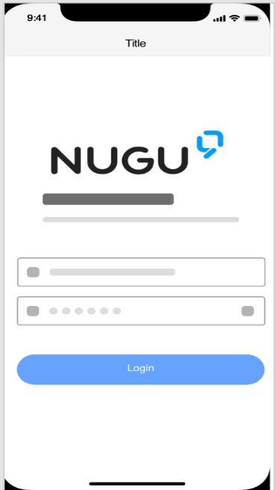

Figure 1. Login

1) Client could login with username

Log-in through certified username. If certification is success, perform access token transmission.

2) After log-in, user could use service

**2.2.2 Set location of home and company**

1) To judge parent’s location and status, need to set longtitude and latitude of home and company

2) User could set marker on map

**2.2.3 Update present location**

1) Send present longtitude and latitude data to server

**2.2.4 View kid’s request log**

1) Provide log of kid’s request in customized UI

**4.2.2 View kid’s notification**

1) Parent could see log list of the request by kids

2) “Kid is finding you” fixed message and timestamp will appear.

**4.2.3 Set location of home and company**

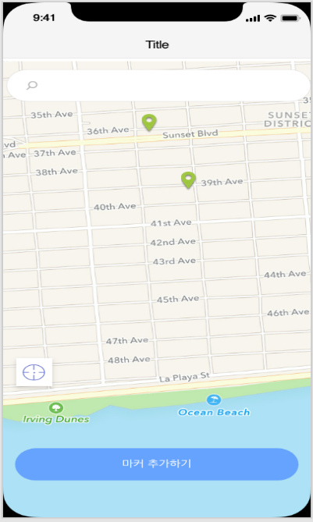

Figure 2. Set the marker

1) Specify a specific location

Use Kakao Map API’s function to search a specific location or return the current location. Set name the location and save it with latitude and longitude.

- location : varchar2(10)

- latitude, longitude : float

Ex) {location :’회사’, latitude:36.232, longitude:35.231}

2) Add marker at the stored location

3) Send user’s current location to server

Use the background feature of the native app to send current location to server. Option for using location information must be checked by user before send this data.

**4.3 Server**

**4.3.1 Judge parent’s location**

Server return different backend parameter depending on parent’s location.

[sudo code]

if CurrentLocation== KnownLocation

return CurrentLocation, status

//{location : ‘company’, status:’working’}

elif CurrentLocation between KnownLocation

and using RandomForest

return KnownLocation, status

//{location:[‘company’, ‘home’], status:’coming’}

else

return Status

// {status : ‘외출 중’}

In between case, use ‘RandomForest’ model. to predict status of parent based on location(longtitude, latitude) and timeStamp.

1) Get parent’s location data from application

2) Check latest location and judge status by customized algorithm

3) Response to NUGU

**4.3.2 Send data to database**

1) Server get data from NUGU speaker and application

2) Server keep these data in database

**4.3.4 Make json for NUGU**

1) Django Rest Framework module could handle this problem automatically.

**5. Architecture Design**

**5.1 Overall Architecture**

Our service is web-based application and heavily depends on Amazon Web Service for deployment. Our application’s UI is implemented with React Native. Server is implemented by Python with Django framework web server on it to serve data to frontend UI as REST API, and interact with SKTelecom NUGU’s API and speaker. Entire API server is running on Amazon Web Service EC2 instance. Figure 1 shows overall architecture of the service.

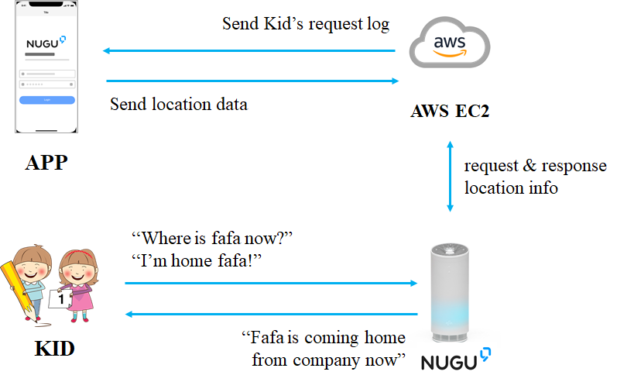

Figure 7. Overall System Architecture Diagram

**5.2 NUGU Architecture Design**

Below are in-voice commands required to make interaction with SKTelecom NUGU Speaker.

**5.2.1 General Setting**

1) Backend Proxy Server

2) Web URL : TBA

3) Exception message : “Connect Error”

**5.2.2 Intent**

1) inform.home

Inform to parent that kids get home now.

Command : (FAMILY_NAME), (ending of word) ex) “Mom, I’m home”

|  |  |  |
| --- | --- | --- |
| **Example mention** | **Mom** | **I’m home** |
| Category | FAMILY_NAME | ending of word |
| Entity | FAMILY_NAE | STATEMENT_HOME |

Action for inform home Intent : alert_NUGU

|  |  |  |  |
| --- | --- | --- | --- |
| **Example mention** | **엄마** | **에게** | **알려드렸어요.** |
| Category | FAMILY_NAME | Postposition | Ending of word |
| Utterance Parameter | FAMILY_NAME | Fixed postposition | Fixed statement |

2) ask.location

Ask for family’s location

Command : (FAMILY_NAME), (ending of word) ex) 엄마 어디야?

|  |  |  |
| --- | --- | --- |
| **Example mention** | **엄마** | **어디야?** |
| Category | FAMILY_NAME | ending of word |
| Entity | FAMILY_NAE | STATEMENT_LOCATION |

- Action for ask.location Intent

a) now_location

When family member is in designated place, now_location tells the location of family member.

|  |  |  |  |  |
| --- | --- | --- | --- | --- |
| **Example mention** | **엄마** | **는** | **회사** | **에 있어요.** |
| Category | FAMILY  NAME | Postposition | Location | Ending of word |
| Utterance Parameter | FAMILY_NAME | Fixed  post position | LOCATION | Fixed Statement |

b) between_location

When family member is between home and company, between_location tells the starting point, destination, and status.

|  |  |  |  |  |
| --- | --- | --- | --- | --- |
| **Example mention** | **엄마** | **는** | **회사** | **에서** |
| Category | FAMILY_  NAME | Postposition | Location | Postposition |
| Utterance Parameter | FAMILY  _NAME | Fixed  postposition | START_  LOCATION | Fixed  Postposition |

|  |  |  |  |
| --- | --- | --- | --- |
| **집** | **으로** | **퇴근하는** | **중아에요** |
| Location | Postposition | Status | Ending of word |
| DESTI_LOCATION | Fixed postposition | STATUS | Fixed Statement |

c) except_location

When family member is not in designated place and not between two designated places, except_location tells family member is gone.

|  |  |  |  |
| --- | --- | --- | --- |
| **Example mention** | **엄마** | **는** | **지금 외출중이에요.** |
| Category | FAMILY_NAME | Postposition | Statement |
| Utterance Parameter | FAMILY_  _NAME | Fixed  postposition | Fixed statement |

**5.2.3 Entity**

1) FAMILY_NAME

Family members

|  |  |
| --- | --- |
| **Parameter** | **Synonym** |
| 엄마 | 어머니 |
| 아빠 | 아버지 |
| 형 | 오빠, 형님 |
| 누나 | 언니 |

2) STATEMENT_HOME

Fixed Statement for ending of word when kid come back home

|  |  |
| --- | --- |
| **Parameter** | **Synonym** |
| 나 집이야 | 나 지금 집이야, 나 도착했어, 나 집왔어… |

3) STATEMENT_LOCATION

Fixed Statement for ending of word when kid ask for family member’s location.

|  |  |
| --- | --- |
| **Parameter** | **Synonym** |
| 어디야 | 어디야, 지금 어디야, 어디에요, 지금 어디에요… |

**5.2.4 Actions**

1) alert_NUGU

- Custom Action

- Using it when kid come back home.

- Trigger

- inform.home

Ex) “엄마, 나 도착했어”

- Prompt

Ex) “{{FAMILY_NAME_}}에게 집에 왔다고 알려 드렸어요.”

2) location

- Custom Action

- Root Action

- Trigger: ask.location

- Output

6.1) now_location

- Branch Action

- Using it when family member is in designated place.

- Trigger: When LOCATION(Backend Parameter) exist

- Prompt

Ex)”{{FAMILY_NAME}}은 {{LOCATION}}에 있어요”

6.2) between_location

- Branch Action

- Using it when family member is going to designated place or home.

- Trigger: When START_LOCATION and DESTI_LOCATION(Backend Parameter) exist.

- Prompt

Ex)“{{FAMILY_NAME}}는 {{START_LOCATION}}에서 {{DESTI_LOCATION}}으로 {{STATUS}} 중이에요”

6.3) except_location

- Branch Action

- Using it when family member is not in designated place or not between two designated places.

- Prompt

Ex) “{{FAMILY_NAME}}은 지금 외출 중이에요.”

**5.3 Database Design**

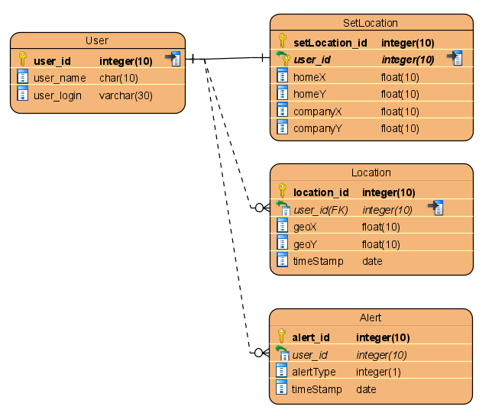

**5.3.1 User**

- user_id(PK) : identification of user

- user_name : user’s name

- user_login : information of user login(like token)

**5.3.2 SetLocation**

- setLocation_id(PK) : identification of SetLocation

- user_id(FK) : reference ‘User’ table

one user could set only one home and company

- homeX : longtitude of user’s home

- homeY : latitude of user’s home

- companyX : lontitude of user’s company

- companyY : latitude of user’s company

**5.3.3 Location**

- location_id(PK) : identification of Location

- user_id(FK) : reference ‘User’ table

one user could make multiple location logs

- geoX : lontitude of user

- geoY : latitude of user

- timeStamp : time of this data made

**5.3.4 Alert**

- alert_id(PK) : identification of Alert

- user_id(FK) : reference ‘User’ table

one user could make multiple alert logs

- alertType : define what request is this

- timeStamp : time of this data made

**5.4 Directory Organization – Front End**

Table 4 shows the directory organization of React-Native frontend application’s project.

TABLE 4. DIRECTORY ORGANIZATION FOR FRONTEND APPLICATION PROJECT

|  |  |  |
| --- | --- | --- |
| **Directory** | **File names** | **Module name in use** |
| /src/components | Index.tsx | styled-components/native |
| /src/Assets/Images | .png | - |
| /src/Screens/Navigator | Index.tsx | react-navigation |
| /src/Screens/Login | Index.tsx | react-native-community/async-storage |
| /src/Screens/CheckLogin | Index.tsx | react-native-community/async-storage |
| /src/Screens/Map | Index.tsx | react-native-maps,  react-native-geolocation-service |

**5.4.1 /src/components**

React-native uses functional-component-based development method. This folder contains components that are frequently used like button, Input components. We will use these components by export and import function.

**5.4.2 /src/Assets/Images**

Inside the Asset folder, there are resources such as image files and fonts needed for the application. There are app icons, button images, and marker images in the image folder images.

**5.4.3 /src/Assets/Screens**

The Screens folder contains functions that make up the screens in the application. Navigator is a function that controls the movement of the screen. The screen consists of a Login screen for logins, a CheckLogin screen for tokens checking, and a Map window for positioning.

**5.4.4 styled-components/native**

Styled Components is an open-source library that helps with the application of styling of react and react native. It can create a style on a single JavaScript file. In other words, you can do CSS work in JavaScript files without CSS files.

**5.4.5 react-navigation**

A React Navigation is a chain of navigators that define the *screen* flow of your app. React Navigation's stack navigator provides a way for your app to transition between screens and manage navigation history.

**5.4.6** **react-native-community/async-storage**

React Native Async Storage is an asynchronous, unencrypted, persistent, key-value storage system for React Native. Async Storage send and receive data like token, user information, location of home and company with Backend Server.

**5.4.7** **react-native-geolocation-service**

React Native Geolocation Service tell user’s current location and allows to track user’s location. Using this module, we took user’s current location and whenever the user’s location changed, we used fetch module to send the location information to backend server.

**5.4.8 react-native-maps**

React Native Maps is a component system for maps. Using this module, we displayed Google Maps on the screen and marked house, company, user’s current location with marker

**5.5 Directory Organization – Back End**

TABLE 5. DIRECTORY ORGANIZATION FOR BACKEND APPLICATION PROJECT

|  |  |  |
| --- | --- | --- |
| **Directory** | **File names** | **Module name in use** |
| /.ebextensions | django.config | Django, AWS ElasticBeanstalk |
| /.elasticbeanstalk | config.yml | AWS ElasticBeanstalk |
| /NUGU | settings.py, urls.py, wsgi.py | Django, Django RestFramework |
| /FAFA | models.py, serializers.py, urls.py, views.py | Django, Django RestFramework |
| /static | .css, .js, .img, | - |
| . | .gitignore, db.sqlite3, manage.py, requirements.txt | Django |

**5.5.1 /.ebextensions**

In order to implement Django module on AWS ElasticBeanstalk environment, path configuration needed. ‘django.config’ file contains option for setting and covers deploy problem.

**5.5.2 /.elasticbeanstalk**

To upload directory on AWS instance, application name or region and the other configuration needed. ‘config.yml’ would cover upload problem.

**5.5.3 /NUGU**

In order to use Django framework which is run by Python, allowed hosts, url, apps, packages and other things should be set on this directory. On ‘settings.py’ and ‘urls.py’ files, there are some customized setting for this project.

**5.5.3 /FAFA**

Django RestFramework module is used in this directory. ‘models.py’ make models (DB table). ‘urls.py’ handles routing. ‘views.py’ gets request and sends response by function that we made. ‘serializers.py’ make response in json form from queryset.

**5.5.4 SQLite**

SQLite is relatively light embedded database for applications. To store data, only one file ‘db.sqlite3’ is needed. Small and concise DB would run in local, so you don’t have to worry about the cost of network configuration, firewalls, network address translation, and so on. We can only focus on code level.

**5.5.5 AWS ElasticBeanstalk**

A fully managed service of AWS that deploy, expand and manage web application. It handles capacity provisioning, load balancing, auto scaling, monitoring, and hosting environment automatically. So user just deploy application. In addition, there is no unnecessary expenditure to pay. Through easy deployment, this module makes us focus on code level during development.

**5.5.6 Django**

Django is Web framework used in our project. Using this module, we don’t ‘reinvent the wheel’ about HTTP service. Django provide simple and convenient middle-ware like routing, error-handler and parser. Many of above middle-ware can be implemented in custom way that we want to make.

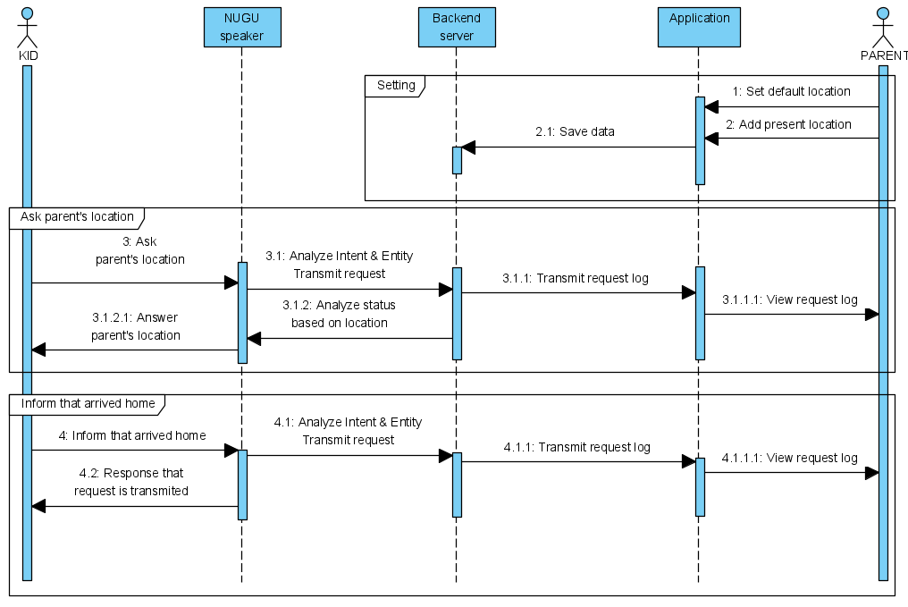

Figure 9. Sequnce diagram

**5.5.5 Django Rest Framework(DRF)**

DRF is a powerful and flexible module for creating WEB APIs. To develop backend proxy server of NUGU-PLAY in REST API form, we used DRF. This module has powerful ‘viewset’ that enables us to develop CRUD functions easily and quickly. Also we can customize a general view.

**6. Use Cases**

FAFA service is used by kids and parents. Kids use our service via NUGU speaker, Parents use our service throguh application that we developed in React Native. Application and NUGU speaker are connected by backend proxy server which is developed in REST API format by Django framework. Under Diagram shows flow of our service and algorithm that how to define parent’s status based on location data.

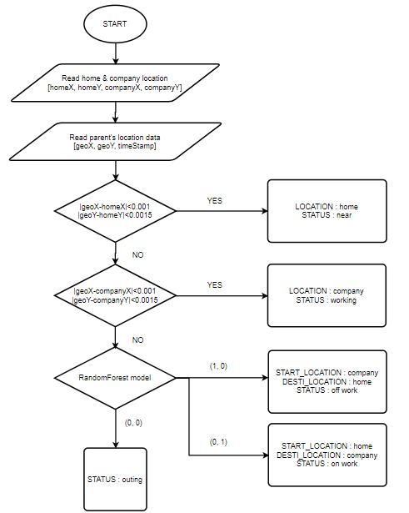

Figure 10. Flow of ‘Anlayze parent’s status based on location’

**6.1 NUGU speaker**

Depending on above algorithm which is using randomForest model to define that parents are coming or going, There are 3 answers when kids ask parent’s location through NUGU speaker. In addition, there is fixed response when inform to speaeker that kids arrived home.

**6.1.1 “Parent is working in office” by speaker**

If parent’s latest location is near to home or office, NUGU speaker tells to kids “Mom is working in office” or “Fafa is near home”. Figure 10 explains this logic. 0.001 longtitude means 100 meter and 0.0015 longtitude means 100 meter.

**6.1.2 “Parent is coming home from office now” by speaker**

We predict parent’s status by using randomForest which is one of Machine Learning method. Train data is saved automatically by application that we made. If kids ask parent’s location, backend server puts parent’s latest location on randomForest model and judge that parents are coming or going home.

**6.1.3 “Parent is out now” by speaker**

If parent’s latest location is out of boundary between home and company. NUGU speaker says “Parent is out now”

**6.1.4 “Told to parents that you arrived home now” by speaker**

If kids inform that they arrived home now, NUGU speaker sends this log to backend server and response above message.

**6.2 Application**

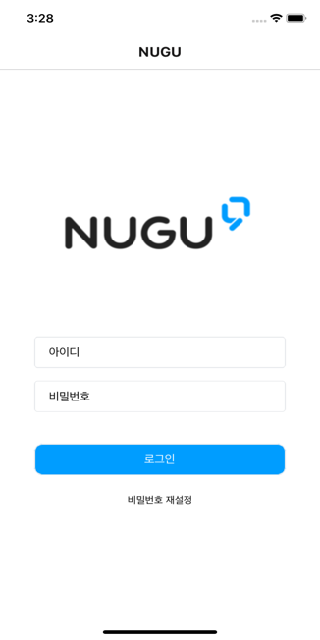

Figure 9. Login

**6.2.1 Login**

When user access our application, They have to login by ID and Password. To use NUGU speaker, they need to log in with their T ID.

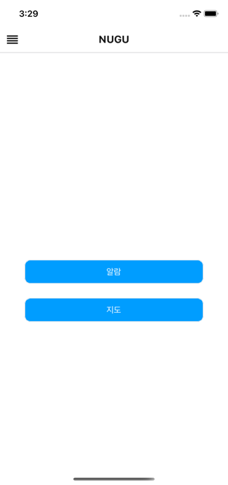

Figure 10. Landing

**6.2.2 Landing**

When user log in to our application, the landing screen is on.

There are two options. One is an alarm page that shows alarm and the other is a map page that track user’s location.

Figure 11. Alarm

**6.2.3 Alarm**

This page shows thar when the child found his parents and when the child arrived home. It informs user of alarm and the time the alarm came.

Figure 12. Check current Location

Figure 13. Indicate that user is going home

Figure 14. Location Tracking

**6.2.4 Check current location**

User can check his current location by Google Map. When user click list button on the upper left corner, user can return to landing screen.

**6.2.4 Indicate that user is going home**

When clicking start button, user tell server that user is on user’s way home. The Start button changes to the arrival button. When the user arrives home, press the arrival button.

**6.2.5 Location Tracking**

Whenever the user’s location changes by more than 100 meters, the location information is sent to the server and displayed on the screen.

**6.2.6 Sending Data for AI’s Learning**

The server analyze the location information through AI and predict the way home. So when enough data is accumulated, it determines whether you are one your way home without pressing start button.

Figure 15. Set Home Location

Figure 16. Set Company Location

**6.2.7 Set Home Location**

When the User press the home button, the current location is set to the home position and a home icon is created.

**6.2.8 Set Company Location**

When the User press the company button, the current location is set to the company position and a company icon is created.